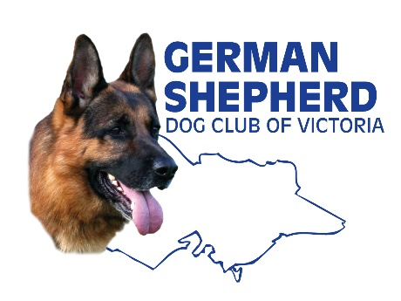
Structural Assessment

On behalf of Breed Affairs, Western Branch will be conducting a Structural Assessment on Sunday 21st May 2023 commencing at 11.30am

This is a great opportunity for members from any Branch to learn more about their own dog’s conformation and the German Shepherd Dog overall.

Dogs must be 18 months of age, and do not have to have papers to participate.
Simply register your interest and complete the required details on the form you will be provided with.
Then just get involved on the day.
Registration forms available from your branch Breed Affairs Liaison Officer or Chief Instructor
What Happens at the Assessment?

The structural assessment loosely follows a GSDCA Breed Survey process, informally applying the GSD Breed Standard. An anatomical description of your dog will be noted, their character and temperament will also be observed and noted. Reaction to the gun noise, height and weight details will be recorded.
You will receive a certificate to keep.
Please note that a Breed Assessment is in no way a recommendation for future breeding.

At the end of the Assessments, there will be a discussion and an overview of the GSD, and you will have an opportunity to ask questions of the Breed Surveyors in attendance, so a great chance to learn heaps!

Make it a really great social and educational day for you and your dog, or come along to support your friends.

See you there !

