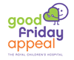
royal children’s hospital
GOOD FRIDAY APPEAL

WE NEED YOUR HELP ARE YOU READY???
15th April 2022

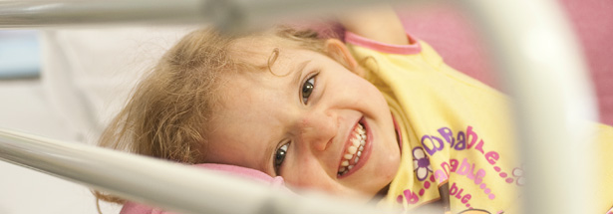

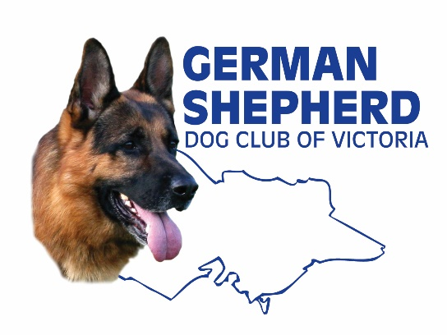 | On 15 April 2021 the GSDCV through its Western Branch will be participating in its  39th Year  of collecting money for the  “Royal Children’s Hospital  Good Friday Appeal”  Overall, we have raised $640,000

We need your help in collecting on designated corners from 8am to 2pm on the day.
If you can spare some time please see your Branch Manager for details or contact the organisers:

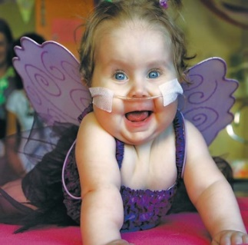
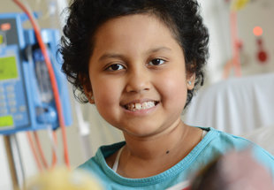
Lyn Pickering (03) 9311-2867 or
Bernie Lester 0409-132-518 or
Dom Cafari 0431-436-897

REMEMBER
“IT’S ALL ABOUT THE KIDS”

